DIGITAL AV
SUMMER SCHOOL

You are cordially invited to spend a few days in the beautiful
Peak District of Derbyshire, honing your digital AV skills

Monday 4th to Thursday 7th July 2011

with
Keith Brown FRPS FIPF EFIAP MPAGB APAGB
Richard Brown FRPS FIPF EFIAP APAGB

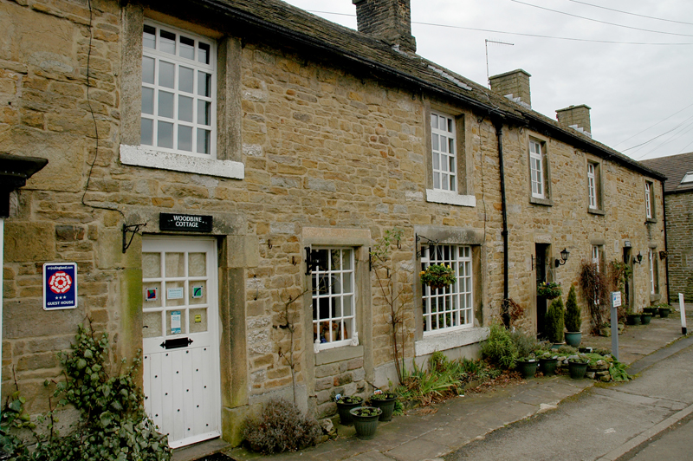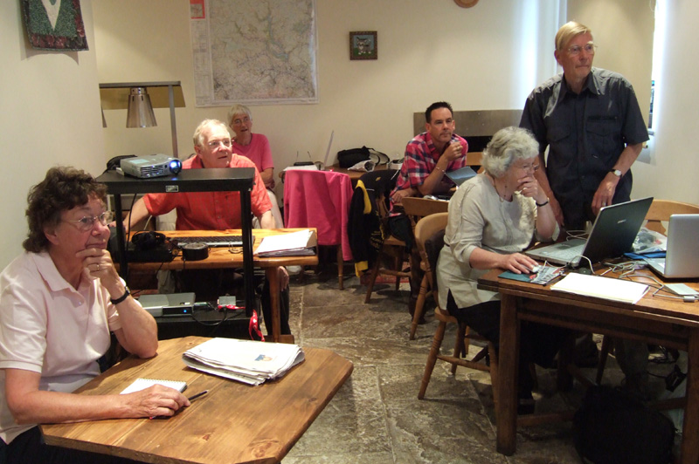

For the third year running, two of the UK’s best-known AV workers will be leading a Summer School at Hope. A mixture of lectures plus showing, discussion and hands-on work on your own sequences. Participants are encouraged to bring their own software, laptops and other equipment for help and advice.

Following the format of last year’s successful event, the Summer School will be restricted to six attendees only, allowing plenty of time for one-to-one help and advice.

Venues: Accommodation, meals and tutorials will all take place in The Woodbine, three adjacent B&B cottages in the centre of Hope (www.woodbine-hope.co.uk). The Summer School will start at 2pm on Monday 4th and finish on the afternoon of Thursday 7th July 2011.

Terms: £205 per person to include three nights B&B, dinner each evening and all tuition.
(Based on two people sharing a double or twin room.) Single rooms may be available at cost of £250 per person.

For further information and bookings, please contact:
Richard Brown 0121 350 4629
Keith Brown 01433 621072

